

**Wednesbury Levelling up Partnership Board**

**Terms of Reference**

**V3 Oct 2024**

1. **Purpose of Document**
   1. The purpose of this document is to outline the governance arrangements for Sandwell’s Levelling up Partnership (LUP).
   2. The governance arrangements are based on learning from the Towns Fund Governance arrangements and reflect the requirements of the Levelling up Partnership from the Department for Levelling Up Housing and Communities (DLUHC).
   3. The document includes Roles and Responsibilities, Code of Conduct for Board Members, Decision Making arrangements, Scrutiny arrangements, Transparency and Accountability and a list of Members of the Wednesbury Levelling up Partnership Board (WLUP Board).
2. **Context**
   1. Levelling Up Partnerships are targeted interventions designed to identify practical, tangible actions to support priority places to ‘level up’ and to help government develop a more holistic understanding of place. The aim is to develop a deeper understanding of the unique challenges and opportunities in priority areas, and via a partnership approach harness collective powers to tackle the most pressing issues. Sandwell is one of the twenty places in England selected to have a Levelling Up Partnership.
   2. Given the nature of the Levelling up Partnership and its focus on co-production, any governance arrangements need to take into account stakeholder input and views not only to the project development process, but to harness stakeholder energy to come together to address the levelling up issues faced by the Town.
   3. The Levelling up Programme stages are set out by MHCLG as follows:

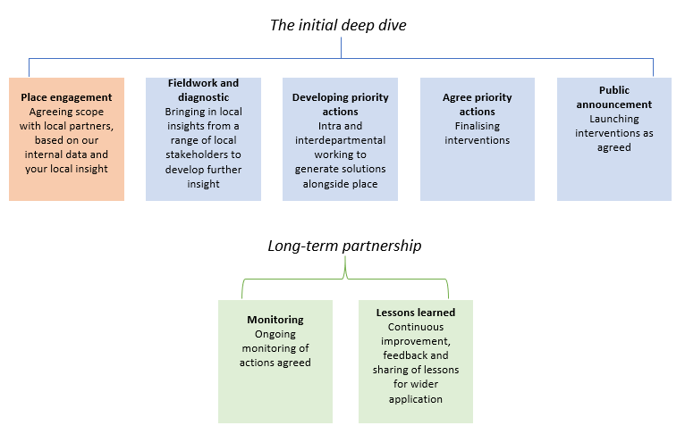

* 1. A bespoke governance board referred to as theWednesbury Levelling Up Partnership Board (WLUP Board)has been established to oversee the delivery of the LUP programme and bring partners together. The Board was established towards the end of the Initial Deep Dive activity.

1. **Governance Model**

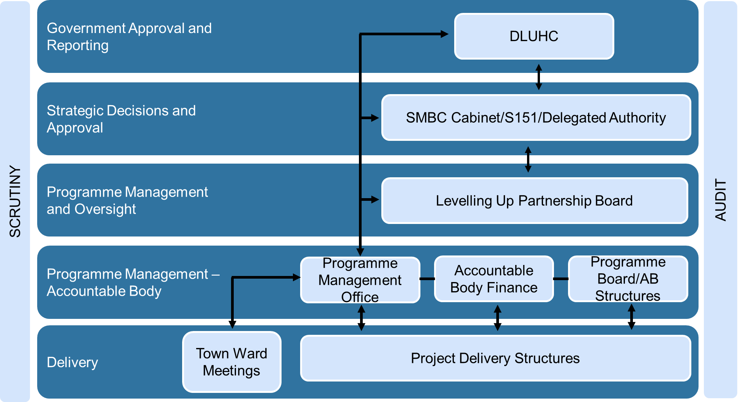

1. **Roles and Responsibilities** 
   1. **Wednesbury Levelling Up Partnership Board (WLUP Board)**
      1. The WLUP Board will be responsible for:

* Leadership/ Direction - Provide strategic direction across the LUP
* Coherent Governance - Ensure a coherent approach to governance within the town (managing interfaces with the Town Tasking Boards and Town Member Meetings)
* Consistency - Ensure interventions are not competitive and act to build the local economy
* Alignment to Strategic Priorities - Ensure alignment of projects to Local, Regional and National strategies
* Stakeholder Engagement – ensuring that communities’ voices are involved in shaping design and decision making and ensuring diversity in its engagement with local communities and businesses
* Upholding the Seven Principles of Public Life (Nolan Principles)
* Ensure compliance with any Heads of Terms Agreements / Grant Conditions / other Agreement issued by DLUHC
* Have sight of and be consulted over project change requests
* Act as a critical friend throughout the programme
* Fulfil any other duties and responsibilities required of the WLUP Board by Central Government
  + 1. The Chair of the WLUP Board will be responsible for: -
* Upholding the Seven Principles of Public Life (Nolan Principles)
* Leading the Board to achieve its objectives, maintaining an overview of activity, and championing the supporting partnership working
* Ensuring that decisions are made by the Board in accordance with good governance principles
* Signing the submissions to Government on behalf of the Board, where applicable

4.1.3 The Vice Chair of the WLUP Board will be responsible for:-

* Upholding the Seven Principles of Public Life (Nolan Principles)
* Deputising for the Chair in the event of absence or conflict of interest
* Supporting the Chair to lead the Board and ensure decisions are made by the Board in accordance with good governance principles
  1. **Sandwell Council**
     1. Sandwell Council is the Accountable Body for Sandwell’s LUP Programme.
     2. Sandwell Council is responsible for: -
* Upholding the Seven Principles of Public Life (Nolan Principles)
* Developing a delivery team, delivery arrangements and agreements
* Ensuring that decisions made by the WLUP Board is in accordance with good governance principles.
* Ensuring transparency through the publication of agendas and minutes of the WLUP Board on Modern.Gov
* Developing agreed projects in detail and undertaking any necessary feasibility studies
* Undertaking any required Environmental Impact Assessments or Public Sector Equality Duties
* Monitoring and evaluating the delivery of LUP projects and impact
* Submitting monitoring reports to Central Government, as required
* Receiving and Accounting for the LUP grant
* Engage with the WLUP Board regarding project changes
* Proactively consult the DLUHC representative on any potential changes to approved plans
* Ensure that all templates submitted to DLUHC are accurate and complete representations of current circumstances

1. **Board Vacancies**
   1. **WLUP Board** – Partner Organisations- Vacancies occurring within the WLUP Board are for the identified organisations to make an appointment to in line with their own governance procedures. Where no such representation is provided, the Board will review the membership to decide whether alternative organisations or community representation are to be invited.
   2. **WLUP Board – Community Organisations, Business Representatives, EDI Representatives –** Consideration will be given to filling vacancies either via i) nominations from suitable infrastructure groups/forums (eg. Faith Sector Network / Business Forum/ VCS forum) with confirmation of appointment provided by the WLUP Board, or ii) via an Expression of Interest process. Should expressions of interest be invited, an Independent Panel agreed by the Board and Accountable Body will be convened to score applications and appoint to the Board
   3. **Elected Members** – SMBC Full Council nominates Councillors and Cabinet Members to represent on the WLUP Board on an annual basis (Appointments to other Bodies). Where the appointed nominees for the WLUP Board does not represent the appropriate Town/ wards for the funding programme, an additional elected member can express their interest, to ensure all Wards are covered. The Chair and Town Lead will make the decision should there be more than one elected member expressing interest for the same Ward. WLUP Board members will cast votes where a decision cannot be agreed.
   4. The Town Lead Member is responsible for reporting progress back to Ward Members via Town Member Board Meetings.
   5. **Young People’s Representatives** - Vacancies occurring in young people’s representation at WLUP Boards will be identified and appointed to via Sandwell Council Youth Service in consultation with the Chair of the WLUP Board, as appropriate.
   6. **Vice Chair –** The Board shall elect a Vice Chair from the Board Membership
2. **Code of Conduct** 
   1. All Members of the WLUP Board will sign the Councillor Code of Conduct which is based on the Seven Principles of Public Life (Nolan Principles) and contained within Article 13 of the Council’s constitution.
   2. Members of the WLUP Board will be required to declare and register any gifts and/ or hospitality which will be maintained by the Council.
3. **Decision Making – WLUP Boards**
   1. The Council’s Principles of Decision Making will apply to the WLUP Board, as laid out in article 13 of the Council’s Constitution. ‘Elected Member’ is taken to refer to WLUP Board member: -
      1. Article 13.02 Principles: -

* Proportionality (i.e. the action taken is proportionate to the desired outcome);
* Decisions are taken on the basis of due consultation and professional advice from officers (Decisions taken by elected members will be based on information provided in a written report prepared by the responsible officer/s);
* Respect for human rights and giving due regard to the Public Sector Equality Duty;
* A presumption in favour of openness (Reports will only be considered in private where they contain exempt information as defined in Schedule 12A to the Local Government Act 1972 (as amended) (see Part 4 Access to Information Rules – Rule 10);
* Clarity of aims and desired outcomes (The written reports submitted to elected members will contain a clear recommendation of the professional officer for every decision they are asked to take)
  1. **Quorum** – the WLUP Board will be considered quorate with one quarter of voting members present.
  2. **Voting** – any matter will be decided upon by a simple majority of those members present in the room and eligible to vote. Where a decision cannot be concluded by a vote, the Chair will have the final decision making authority.
  3. **Confirmation of minutes** - The Chair presiding shall put the question that the minutes submitted to the meeting be approved as a correct record.
  4. **Declarations of Interest**
     1. Members shall be required to declare interests in accordance with any relevant statutory provisions and the Members’ Code of Conduct as set out in Part 5 of the Constitution.
     2. Where a WLUP Board member has a disclosable pecuniary interest or pecuniary interest in the business of the authority he/ she must withdraw from the room or chamber where the meeting considering the business is being held unless the member has obtained a dispensation from the Council’s Monitoring Officer.
     3. Where a WLUP Board Member is nominated as the Lead Officer for a project and/ or is involved in project delivery, they may attend the WLUP Board discussion relating to the project in the capacity of providing and presenting information but they may not participate in any deliberations or decision by the WLUP Board concerning that project.
  5. In the event that WLUP Board wishes to move to a vote, any matter will be decided upon by a simple majority of those members present in the room and eligible to vote.
  6. The Chair shall have a second or casting vote.

1. **Scrutiny** 
   1. Scrutiny of the Levelling Up Partnership Programme will be provided by the Council’s Budget and Corporate Scrutiny Management Board and/or Economic, Skills, Environment and Transport Scrutiny Board, as required by scrutiny and through the critical friend challenge that will be provided by the WLUP Board.
2. **Transparency and Accountability**
   1. **WLUP Board Agendas and Minutes** 
      1. The Council will publish WLUP meeting agendas on Modern.gov 5 clear days before the meeting.
      2. Draft minutes of the WLUP Board meetings will be published within 10 clear working days or a meeting and
      3. Approved minutes of the WLUP Board meetings will be published within 10 clear working days of formal approval.
   2. **Member profiles**
      1. Profiles of WLUP Board Members will be published on Modern.gov.uk
   3. **Conflicts of Interest**
      1. Members of the WLUP Board will be required to declare any conflicts of interest (commercial, actual and potential). This will be maintained by the council in a declaration of interest register which will be managed by Sandwell Council.
      2. WLUP Board Members should take personal responsibility for declaring their interests before any decision is considered by the WLUP Board. These will be formally noted within the published minutes of meetings of the WLUP Board including action taken in response to any declared interest.
      3. WLUP Board Members should take personal responsibility for declaring their interests prior to an item being discussed. These will be noted within the minutes including action taking in response to any declared interest. If any Member has any queries about their interests and the disclosure thereof, they should seek advice from the Monitoring Officer.
3. **The Board’s relationship with Sandwell Council**
   1. The Board will have sight and endorse Accountable Body decisions in the delivery of the Levelling Up Partnership Programme. Sandwell Council is the Accountable body for any LUP funding that is received, or any match funding received in relation to LUP projects.
   2. These Terms of Reference do not change, replace, substitute for or amend in any way the statutory powers or duties or other responsibilities of any of the people or organisations represented on the WLUP Board.
   3. The procurement policies of Sandwell Council will apply. Where external professional advice is required, consultants will be identified using the procurement policies of Sandwell Council and contracts will be entered into between Sandwell Council and the relevant organisation in accordance with Sandwell Councils policies and procedures including its contract procedure rules.
   4. Where applicable, Sandwell Councils Cabinet will receive regular reports on progress of activities through regular performance monitoring.
   5. Board Members shall make themselves available from time to time to meet Cabinet and / or Portfolio Holder and to attend meetings of the Council’s Scrutiny Committee if invited.
   6. The council’s Data Protection Officer and the PMO will support the Board in dealing with any data protection questions. The councils framework can be found at Information Governance and Data Protection.
4. **Membership**
   1. The Council has responsibility for establishing the WLUP Board for the development and implementation of the Sandwell Levelling Up Partnership.
   2. Membership will be reviewed annually and seek to continue to be representative of a diverse range of sectors, skills and interests in Sandwell in order for this to be drawn on at all stages of the LUP implementation.
   3. The updated membership will be reported to Cabinet at least on an annual basis to align with Annual appointments.
   4. All Board members are expected to attend at least a minimum of 50% of the annual meetings held, unless exceptional circumstances which have been agreed by the Chair.
   5. Advisors – Advisors are invited by Board Members and participate in the meetings but will have no voting rights or ability to make decisions on behalf of the Board. Advisors may also be invited to participate in issue-specific discussions / spotlight sessions.
   6. S151 Officer – Sandwell Council is the Accountable Body for the LUP. The Council’s S151 Officer or substitute will have a standing invite on the LUP Board to ensure compliance with all necessary financial regulations.
   7. **Observers -** Non-participating observers may be allowed to attend meetings of the WLUP with prior agreement of the Chair. Any observers in attendance will be permitted to address the Board or speak on a matter only with prior agreement of the Chair
   8. **Deputies** - In the event that a Board Member is unable to attend a meeting(s), a pre-named deputy may attend and cast their vote. Deputies must reflect the appointment type e.g. alternative Elected Member from the same ward e.g. alternative representative from a local business. Notification of a named deputy must be received in writing no less than 1 working day prior to the meeting. Where a deputy is to attend frequently, a named deputy should be agreed.
   9. These terms of reference may be reviewed and modified at any time in consultation with the Monitoring Officer, Assistant Director – Legal and Assurance
5. **Scheme of Delegation**
   1. The Scheme of delegation in decision making is included as an annex to these Terms of Reference. It will be reviewed, and if necessary, updated, following receipt of Government LUP Grant and/or other grant conditions.
   2. A decision which is made in contravention of the process will be invalid based on non- compliance unless the WLUP Board has given prior approval for variation in the decision-making process.
   3. Any financial decision must be signed off by Sandwell’s S151 Officer as the Accountable Body. The Council’s S151 Officer will ensure compliance with all necessary financial regulations, in order to protect the Accountable Body and ensure proper administration of all financial affairs.
   4. The Chair of the WLUP Board can decide to convene a meeting where decisions need to be considered by the WLUP Board which does not fit within the timeframe of the scheduled meetings. Where possible, the standard notice period will apply for any such meeting.
   5. Where a meeting cannot be convened, urgent decisions can be endorsed by the WLUP Board through a written procedure.
   6. Only in the most exceptional circumstances might it be considered necessary and appropriate for a matter of strategic importance usually reserved to the Main Board to be decided through this procedure. This will apply where a project cannot continue without a decision being approved, therefore posing a significant risk to project deliverability. This includes, but is not limited to:

(a) Time limited reallocation of funding

(b) Changes to Heads of Terms / Grant Conditions

(c) Changes to Mandatory Indicators and financial profiles

* 1. Written/Urgent Procedure: -
     1. Following consideration by Assistant Director – Spatial Planning and Growth/S151, a report in the usual meeting format and including reasons for urgency, will be circulated to the Chair/Vice chair to consider whether, due to the urgent nature of the decision to be made, it is necessary and appropriate for the decision to be made before the next meeting.
     2. The Chair/Vice Chair may consult with Assistant Director – Spatial Planning and Growth /S151 or other officers to provide further information where required.
     3. Within 5 working days of the report being presented, the Chair/Vice Chair will inform whether the decision is endorsed on behalf of the Board.
     4. For transparency the report, reasons for urgency, and decision will be presented to the next Board meeting.

1. **Objections following Consultations** 
   1. Project Leads will present any objections that have been received following consultation on Levelling up Partnership projects to the WLUP Board. The WLUP Board will consider the objections and alternative options prior to making a decision in consultation with the appropriate Cabinet member.
   2. In the event that a decision cannot be agreed between WLUP Board and Cabinet member, a separate meeting will be held with the Leader, Cabinet Member, Chair of WLUP Board and Director of Regeneration and Growth to discuss/resolve difference of view.
   3. The project will not proceed in the delivery phase until a decision has been made

**Version Control**

|  |  |  |
| --- | --- | --- |
| **Version number & Date** | **Status** | **Summary of changes** |
| v3 October 2024 | Approved 16/10/24 | Update to process for appointing to vacancies – clarity purposes  Provision for Observers  Provision for Deputies  Update to Officer Titles – clarity purposes  Update to MP Title – clarity purposes  Increase of young people’s representatives – up to 2 positions  Update to change control process with MHCLG |

**ANNEX 1 WLUP Board Membership List**

|  |
| --- |
| **Voting Members** |
| Independent Chair |
| Elected Members x4   * Cabinet Member representative * Town Lead Member * Deputy Town Lead Member * One Member from each Ward (Friar Park, Wednesbury North, Wednesbury South) not covered by Town Lead and Deputy Town Lead appointments |
| Business Community Representatives x1 |
| Voluntary and Community Sector Representative x2  *To include Chair of the Friar Park Millennium Centre as one of the LUP projects* |
| Organisations in Wednesbury representing residents with protected characteristics and of different faiths x3 |
| Public Sector Organisations x2   * West Midlands Police * TfWM |
| Young People’s Representative Up to 2 |
| MPs x1 *(MPs relevant to Wednesbury Town geography)*  MP for Tipton and Wednesbury Constituency |
| **Non-Voting Board Members (Advisory)** |
| MHCLG Representative x1  *To be identified by MHCLG* |
| WMCA Representative x1  *To be identified by WMCA* |
| Homes England Representative x1  *To be identified by Homes England* |
| Accountable Body Representatives  S151 Officer  Assistant Director – Spatial Planning and Growth  Director Public Health  Monitoring Officer  **Or their nominated deputies** |

**ANNEX 2**

|  |  |  |  |  |
| --- | --- | --- | --- | --- |
| **Type of Variation** | **Scale of Variation** | **Requires WLUP Board endorsement?** | **Delegated Authority to approve** | **Approval required from MHCLG** |
| **Financial** | A decrease/increase of **grant funds** to be drawn down by the project which is less than £250,000 | Yes | Assistant Director – Spatial Planning & Growth in consultation with Cabinet Member and S151 Officer | Dependent on outcome of discussion with MHCLG Area Lead. Discussed on a case-by case basis. |
| A decrease/increase of **grant funds** to be drawn down by the project which is greater than £250,000 |
| Any decrease of match funding |
| An increase in the match funding cost of the project without impact to the agreed funding for the project, the outputs/ outcomes or project completion | No | LUP Programme Manager |
| **Time/ Schedule** | Slippage of milestones with no effect on total grant, completion date, outputs/outcomes | No | LUP Programme Manager |
| Slippage of outcomes and/ or grant claim profile, requiring re-profiling across future financial years with no overall change to project | Yes | Assistant Director – Spatial Planning & Growth in consultation with S151 Officer |
| **Outcomes/Outputs** | An increase in the outputs and outcomes of the project | No | LUP Programme Manager |
| Any decrease to outputs and outcomes of the project | Yes | Assistant Director – Spatial Planning & Growth, in consultation with S151 Officer and Cabinet Member |
| Any decrease to Local Measures | Yes | Assistant Director – Spatial Planning & Growth |
| **Other** | Changes to project contact information, administrative errors and others which have no impact to approved outcomes, outputs or grant. | No | LUP Programme manager |