**FAQ’s - Friar Park Urban Village remediation project**

**New / Updated FAQs**

1. **NEW What does remediation mean?**

Land remediation is the process of removing contaminants from the ground which have been left behind from previous uses. The aim is to restore the land to a condition where it can be used for other uses in a safe way. It is essentially all about making land safe for both people and the environment.

The processes involved are subject to strict testing and monitoring in line with the requirements of the Environment Agency, who set national standards required for the proposed end land use, approve the proposed works through the issuing of permits (this is separate to obtaining planning permission), and who are ultimately responsible for certification that the work is completed to a relevant standard.

In the case of land at Friar Park Urban Village, the intention is to treat the material on site, and use it to create plots for housing development, and area of landscaped public open space. The use of the cleaned material in this way will also ensure that the amount of soil taken to landfill is limited and ensures the number of lorries required to access the site is kept to a minimum.

All the work will be undertaken in accordance with the Environment Agency permit. The land cannot be developed until the remediation work is completed to the Environment Agency standards.

1. **NEW Is the project cleaning up the area or building houses?**

The objective of the Friar Park Urban Village Remediation Project is to clean the contaminated land to create a development platform for future use and to carry out landscaping works. This includes but not limited to; levelling out land in areas that need it and building a buffer between the railway and the treated land.

The purpose of doing this is to get the land to a standard where it can be developed on in the near future. A developer will be appointed to progress the housing scheme and will engage with the local community on their proposals to build houses on the site. The masterplan published in 2023 shows how the site may be laid out.

1. **NEW The plans don’t seem to include a new school. Will there be enough school places in the area?**

The current project seeks to clean up the land on the site. Given that no housing development will take place as part of this project it is not necessary to consider any requirements for school provision.

Proposals for housing development will be subject to a separate application for planning permission once a developer is selected. Any additional requirements for school provision would normally be considered as part of the planning application for housing development. Where it is identified that additional provision is required, funding contributions from the developer can be secured through the planning conditions to meet the requirement.

The masterplan for the Friar Park Urban Village did not anticipate a requirement for any new school provision. For a housing scheme of circa 630 properties as proposed at Friar Park, Government guidance estimates that approximately 230 school aged children will reside in the new housing. Current school population trends and projections for the forthcoming years indicate that the local area will see an overall reduction in the number of school places required which will provide sufficient capacity for any new families that move into the area. Therefore, it is not considered that the scheme will have an adverse impact on school provision.

Projections for school places have already been incorporated for the new houses being built by Persimmon Homes on the former Phoenix site

1. **New Its difficult to get an appointment with my GP at the moment. Will there be enough GPs for all the new houses in the area?**

The current project seeks to clean up the land on the site. Given that no housing development will take place as part of this project, it is not relevant to consider any requirements for additional GP provision.

Proposals for housing development will be subject to a separate application for planning permission once a developer is selected. Any additional requirements for GP provision would normally be identified following consultation with the NHS Black Country Integrated Care Board (ICB) as part of the application process, and where it is identified that additional provision is required, funding contributions from the developer may be secured through the planning conditions to meet the requirement, or, the NHS may choose to fund any additional requirement.

The Black Country Integrated Care Board (BCICB) was consulted on the masterplan for the Friar Park Urban Village site in early 2023. At this point in time, there were ten GP surgeries and five dentistry practices within two kilometres of the proposed site, the nearest being the Tame Valley Medical Centre on Friar Park Road and Crankhall Lane Dental Practice and The Village Medical Centre. In relation to the masterplan, the Integrated Care Board (ICB) confirmed that there would be scope to expand other existing facilities in the catchment area and there is not a requirement to provide a new facility as part of the housing development.

In April 2025, the ICB confirmed that the position above still applies.

It is also noted that since the masterplan consultation, planning permission has been granted for an extension to the Tame Valley Medical Centre.

1. **New There is construction work taking place and this is creating dust. I’m concerned about my family’s health.**

There are currently no works being undertaken on the Friar Park Urban Village site. The construction period is expected to commence in 2026.

Before any works to remediate the site starts, planning permission and the Environment Agency permit will be required. It is anticipated that these consents will be in place towards the end of 2025. Both will be subject to a Construction Environment Management Plan, which sets out details as to how issues such as dust, dirt, noise and other disturbing activities will be managed to limit the impacts on neighbours to the site. Failure to comply with the requirements of the plan can lead to enforcement action.

There are other developments taking place in the Friar Park Ward including at the Former Phoenix Academy site. One of the conditions associated with the planning permission on this site required the submission of, and adherence to a Construction Environment Management Plan, which specifically required details of controls relating to emissions arising from dust and dirt during demolition and construction activities. The approved Construction Environment Management plan for the Persimmon Development can be viewed here: [Construction Environment Management Plan - Former Phoenix site](https://webcaps.sandwell.gov.uk/publicaccess/applicationDetails.do?activeTab=documents&keyVal=SMZL7ENRHG500)

Any concerns relating to any development can be reported to the Planning Enforcement team who will investigate and, if necessary, take appropriate action. You can report concerns here <https://www.sandwell.gov.uk/planning/planning-enforcement-1/6>

1. **New Who is the Development Partner and what will they do?**

An announcement of the appointed development partner is expected to be made in early August 2025. The developer will be responsible for clearing up the land and creating detailed plans for the house-building phase.

1. **New When will a planning application be submitted? How do I add my views?**

A planning application for the remediation phase of the project is expected to be submitted in Summer 2025. This will cover the remediation works only. This will be available for public comment on the [Sandwell Council Planning Portal.](https://www.sandwell.gov.uk/planning/view-planning-applications)

Sandwell Council carried out a consultation exercise in October and November 2024 which involved sharing details of the remediation proposals and providing individuals with the opportunity to leave comments. Although, the consultation period is closed, you can still view the proposal information that was shared to the public, using the web link below: <https://consultationhub.sandwell.gov.uk/regeneration-growth/friar-park-urban-village-land-remediation/>

Once a planning application for the remediation is made, there will be opportunity for comments to be submitted through the Council’s planning portal which can be accessed using the web link: <https://www.sandwell.gov.uk/planning/view-planning-applications/2>

1. **New When can I comment on the housing proposals on the site?**

A separate planning application will be submitted by the Developer for the house building phase.

Once a planning application for the housing is made, there will be opportunity for comments to be submitted through the Council’s planning portal which can be accessed using the web link: <https://www.sandwell.gov.uk/planning/view-planning-applications/2>

1. **Updated There is construction work taking place, but the latest information says that the start on site won’t be until 2026.**

There are currently no construction works being undertaken on the Friar Park Urban Village site, although there are other developments taking place in the Friar Park Ward.

* Former Phoenix Academy site – Persimmon Homes are developing this site.
* Medical Centre Extension – Planning permission has been granted for the extension to the Tame Valley Medical Centre.

Site survey work is ongoing on the Friar Park site. This work is necessary to help inform the Environment Agency permit application and planning application for the remediation works.

1. **Updated What social housing will be available?**

The current project seeks to clean up the land on the site. Given that no housing development will take place as part of this project, the provision of affordable housing is not required. Proposals for housing development will be subject to a separate application for planning permission, which will contain proposals for the provision of affordable housing to contribute towards local housing needs.

In accordance with local planning policy, and as set out in the masterplan in 2023, a minimum requirement will be for the scheme to provide 25% affordable housing. Tenders have been sought from developers to provide this minimal level of provision.

1. **Updated When will work begin and finish?**

The estimated timeline for the project is shown on table 1.

*Table 1 estimated timeline*

|  |  |
| --- | --- |
| **Obtain relevant consents for works** | Late 2025 |
| **Remediation Works start** | Early 2026 |
| **Remediation Works completed** | December 2027 |
| **Housing Development starts** | Late 2028 |
| **Housing Development completed** | Summer 2035 |

We are aiming to have all the necessary consents in place to commence the remediation works by early 2026. It is anticipated to be completed in approximately 2 years.

Whilst the remediation works are progressing, the developer will obtain planning permission for the housing scheme. It is expected that housing construction will commence in 2028, and the whole site completed by around 2035.

**Previous FAQs**

1. **What is proposed?**

The land has been proposed for housing development for nearly 20 years. However, given the sites previous use, particularly as a sewage works, the land needs to be treated before it can be developed, and to date the costs associated with this have made development financially unviable. Funding has now been secured to undertake the remediation works to clean the site, which will ultimately allow housing development to take place.

The most effective way of undertaking the remediation is to excavate the material, treat it and then re-use it on site. We propose that the re-used material creates a bund which will form a linear parkland along the eastern boundary of the site to create a landscaped buffer between Bescot Sidings and the M6. The works will also result in moving some treated material around to create flat areas suitable for housing development to create the Friar Park Urban Village in line with the proposed masterplan that was approved by Sandwell Council in March 2023 (see figure 1). This will see around 630 new homes delivered within the next decade.

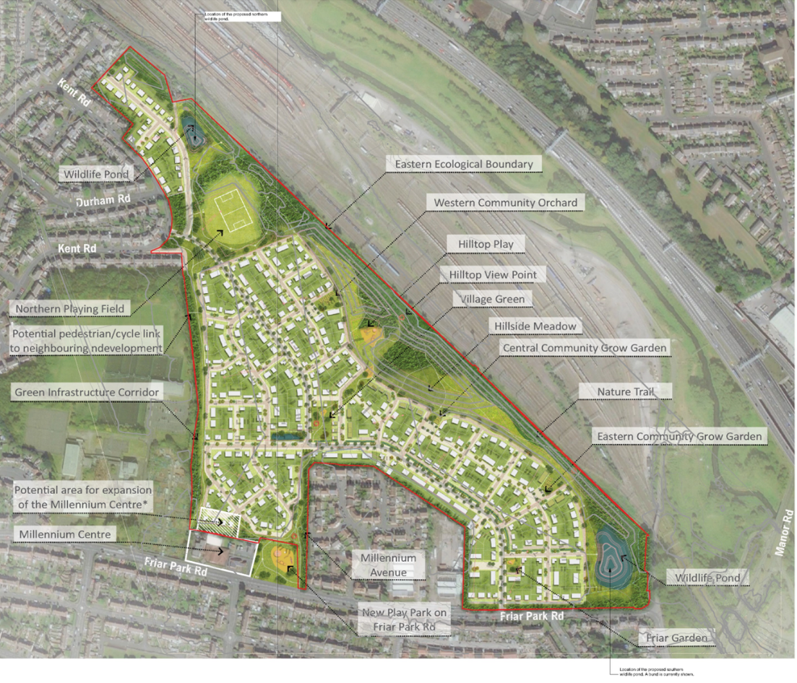

Figure 1 Friar Park Masterplan.

1. **Where exactly are the works taking place?**

The remediation and treatment works will impact on much of the site but most particularly areas in the central and southern parts of the site boundary as shown on figure 2.

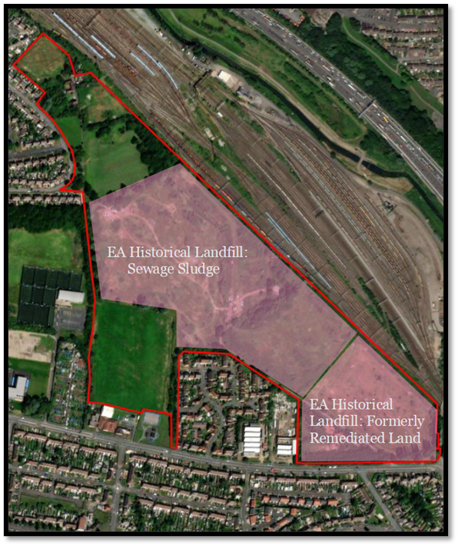

Figure 2 Area where the majority of remediation works will take place.

1. **What work will be undertaken, and how will they be carried out?**

The works will have to comply with the strict terms of Permits issued by the Environment Agency and any conditions imposed on any planning permission by Sandwell Council.

The works will include the following:

* Material will be removed up to 6 metre deep in some places.
* Most of the waste material will be treated on site using specialist equipment to clean it thoroughly.
* The treated material will then be redistributed on the site to create the level areas for housing development and a bund on the eastern boundary (adjoining the railway line) which will form a new linear park. This will improve the environment on the site by creating a landscaped edge, reducing noise and poor visual outlook from the M6 Motorway, Bescot Sidings and the railway.
* The site will then be suitable for construction of the proposed residential development.

1. **Why is it happening?**

Sandwell Council needs to ensure that there is sufficient housing for its population, but for a long time there have been too few sites to meet all the housing needs. The site, once remediated, will contribute towards the overall provision of new housing in the borough. This will include provision of affordable housing through registered providers (e.g., Housing Associations).

1. **What impact will it have on me?**

It will depend on exactly where you live and how close you are to the site. The main area of work will be within the area of the former sewage works and where previous landfill activities took place. However, other parts of the site may also be subject to some works, although not to the same degree.

We aim to control any impacts that might result in disturbance to neighbours to a minimum. Strict environmental requirements will be put place to control:

i) odours (smells)

ii) dust

iii) noise

iv) Asbestos and pathogen (note - the highest risk is to on-site construction workers rather than the local community).

There are many ways our contractors will manage these impacts, but as a minimum we will require the following methods to be utilised:

* Water sprays and suppressors to reduce the spread of dust (see figure 3). Water run-off will be managed though specific drainage measures.
* The use of Mobile odour suppression units to limit the release of smells from extracted material.
* Asbestos risks will be controlled by an asbestos management plan and associated monitoring.
* Controlling hours of working - typically limited to 8am – 6pm Monday to Friday and 8am – 12noon on Saturdays but may be subject to further restrictions through planning conditions.
* Methods to control noise such as:
  + - the use of internal haul roads
    - use low noise/low vibration equipment where possible
    - noise management monitoring to ensure noise levels are within accepted targets
    - use of acoustic shielding (e.g. acoustic fences)
* Comprehensive management of traffic movements on and off-site:
* Regular monitoring of site operations to identify any emerging concerns:
* Continuous communication with local residents to ensure any issues raised are addressed as far as practicable, and without delay.

The risk assessment and proposed control measures for odour, dust and any other items will be recorded within an Environmental Risk Assessment. A dust and odour monitoring and management plan will be implemented to control emissions and will be recorded within a Monitoring Plan. Both of these documents will form part of the permit application, and the Environment Agency will require compliance with these measures during the works as part of permit conditions.

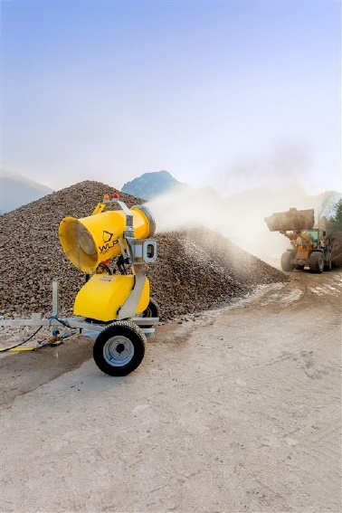

Figure 3 Dust suppressor to reduce the spread of dust.

1. **Will I be able to access the land whilst the works are taking place?**

No, whilst works are taking place, members of the public will not be permitted to use the land for health and safety reasons. However, in the longer term, and once the Urban Village project is completed local people will have access to the site and will be able to enjoy the much-improved public open space, including the new linear park.

1. **Will there be any disruption to traffic flow?**

The number of vehicles visiting and leaving the site during the proposed works will be limited, given most of the waste material treatment will be undertaken on site. These arrangements will be managed by the contractor and conditions will be imposed to control site access and hours of operation to minimise any impacts on nearby residents.

1. **How many vehicles will be on site and where will they be accessing the site from?**

Number of vehicles on site is yet to be confirmed. Access will primarily be from Friar Park Road. Arrangements will be put in place to limit any impacts on local residents. Further information will be provided when available.

1. **What will the site look like after the works are complete?**

The site will be changed in level to create development areas suitable for housing and a raised bund will be created to accommodate a linear park which is shown on figure 4.

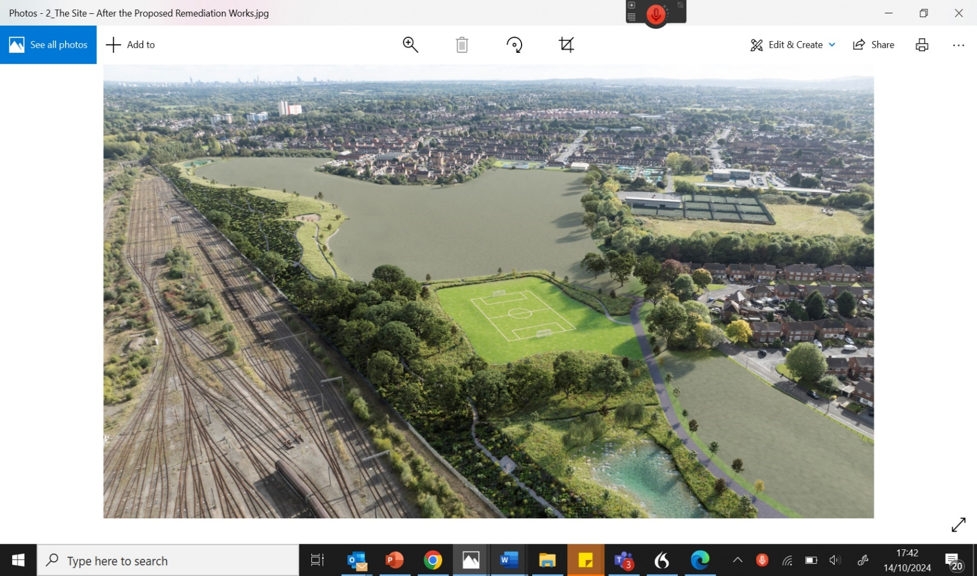

Figure 4 The Site after the proposed remediation works.

1. **What will happen to existing vegetation and animal habitats?**

Given the scale of the remediation works required, a large part of the site will be affected, and it’s unlikely that all the existing vegetation will remain, and there is potential for animal habitats to be disrupted.

However, to meet planning and legislative requirements, ecological surveys have been undertaken on the site over this summer to confirm the presence and extent of any species or habitats of value. It is a legal requirement to ensure that additional habitat is re-provided, either on site or elsewhere to ensure an uplift of a minimum of 10% over what is already present. A mitigation strategy will be created to safeguard wildlife where practicable and to compensate for habitat loss and meet biodiversity net gain requirements where needed. The strategy will be subject to scrutiny by the local planning authority (Sandwell Council), the Wildlife Trust and Natural England. Where required, appropriate licencing will be obtained with respect to any protected species.

1. **Who owns the land, and who is promoting the scheme?**

The site is jointly owned by the West Midlands Combined Authority and Sandwell Council. The two authorities have created a partnership to ensure both sites are comprehensively developed to provide much needed new homes and associated public open space. They will progress the remediation works once a developer is selected. The remediation is being funded by Sandwell Council, the West Midlands Combined Authority alongside funding from HM Government through the Levelling Up Partnership.

**Key words:**

* **Sandwell Council** - are the local planning authority given the land is geographically located within Sandwell.
* **West Midlands Combined Authority** – the combined authority for the West Midlands.
* **Environment Agency** – A Government Agency who are the regulatory body responsible for confirming that the standards of remediation are suitable for future housing development.
* **Contaminated land** – land that has substances that have potential harm to health and/or environment.
* **Remediation** - process of removing contaminants from a site with the aim to restore land to a condition in which it can be developed upon.
* **Bund** – a bank of material that is formed together to create a structural mound that will form part of the landscaped works as part of the scheme.
* **Haul Road** – A temporary route within the site which is used for moving material around; thus, avoiding using the local road network as much as possible.
* **Mitigation -** proposals that are put in place to negate or minimise any impacts that arise from the scheme.
* **Mitigation Strategy** – a plan which demonstrates how proposals can be put in place to negate or minimise any impacts that arise from the scheme.
* **Registered Provider** – a private provider of social housing registered with the Housing Regulator.
* **Levelling Up Partnership** – Central government funding pot to deliver a series of projects which are focused upon levelling up places in most need.