`

Community Safety
Wednesbury Levelling Up Partnership Report

Contents

Executive Summary 3
Introduction 5
Aims and Outcomes 7
Evidence & Impact 12
Social Value and Community Benefits 27
Outcomes & Learning 29
Appendices 31

Executive Summary

This report has been prepared for the Wednesbury Levelling Up Partnership Board and key stakeholders including council services, the Anti-Social Behaviour (ASB) and CCTV teams, West Midlands Police, and local community partners. It presents the delivery, outcomes, and learning from the Wednesbury Community Safety Programme.

Launched in November 2023 and completed in March 2025, the Wednesbury Levelling Up Partnership Community Safety Project was a targeted, place-based intervention designed to address concerns around crime, anti-social behaviour (ASB), and perceptions of safety. Drawing on local data, community feedback, and multi-agency intelligence, Sandwell Council worked in partnership with residents, businesses, and key services to deliver practical and locally informed solutions.

Over 2,200 direct engagements were delivered with residents, businesses, community groups, and partners, shaping every stage of the programme. Physical improvements included upgraded CCTV, deployable cameras, and nuisance bike deterrents at hotspot locations.

The project formed part of the Government’s Levelling Up Partnerships programme, with £400,000 capital funding secured from the Department for Levelling Up, Housing and Communities (DLUHC), now the Ministry of Housing, Communities and Local Government (MHCLG). The work aligns with the priorities outlined in Sandwell’s Community Safety Strategy 2022–2026 and the Strong and Resilient Sandwell Neighbourhoods Strategy 2024–2027, which focus on building safer, thriving, and resilient communities.

By adopting a community-led and multi-agency delivery model, the project achieved measurable improvements in public safety, strengthened trust between agencies and residents, and increased confidence in local services. Social value outcomes included local clean-up days, youth-focused safety improvements, and employment mentoring through the community payback scheme.
Context and Need

Feedback gathered through the Sandwell Residents’ Survey, the SHAPE Young People’s Survey, and a series of targeted local engagement sessions consistently highlighted four key safety concerns in Wednesbury:

- Persistent anti-social behaviour (ASB), often linked to drug-related activity
- Widespread nuisance caused by the illegal use of off-road bikes
- Low visibility of enforcement officers and a desire for increased police presence
- Significant concern around personal safety, particularly at night, with over one-third of Wednesbury residents reporting feeling unsafe after dark — the highest rate across all Sandwell towns

Crime data reinforced these perceptions, with assaults and shoplifting consistently ranking among the most reported offences. Local intelligence, including inputs from the ASB team, ward councillors, and police partners, confirmed that underreporting was masking the true scale of ongoing safety issues.

In response, the Young People’s Corporate Plan called for expanded CCTV coverage and enhanced visibility in public spaces, particularly in and around greenspaces, schools, and the town centre.

These combined insights formed the case for a targeted, place-based intervention in Wednesbury — one designed to improve both actual safety and the perception of safety, by directly responding to local priorities, data, and lived experience.

Introduction

This report outlines the focus, delivery, and impact of the Wednesbury Levelling Up Partnership Community Safety Project, a place-based programme designed to address local concerns around crime, anti-social behaviour (ASB), and public confidence. It documents how a series of targeted safety initiatives were delivered across the town through coordinated partnership working between the council, police, and local communities.

The project centred around three core interventions:
- Upgrading and expanding fixed CCTV coverage, alongside the purchase of deployable surveillance cameras
- Installing a new town centre radio system to strengthen communication between businesses and enforcement partners
- Implementing targeted nuisance bike deterrent measures across greenspaces and public routes

A dedicated Community and Business Engagement Officer role was funded specifically through the Levelling Up Partnership. This role was instrumental in facilitating local engagement, driving delivery, and ensuring the programme remained responsive to community needs and priorities.

The work was delivered in close collaboration with Sandwell Council’s Anti-Social Behaviour (ASB) Team, CCTV Team, West Midlands Police, ward councillors, local schools, businesses, and community groups. Community intelligence, multi-agency data, and ongoing feedback informed every stage of the project, ensuring that it was both community-informed and community-led.

This report demonstrates how these interventions:
- Met project aims and directly addressed local safety concerns
- Strengthened partnership working and increased local visibility
- Improved crime and ASB reporting through enhanced public confidence
- Enabled the prevention, disruption, and detection of local offences
- Positively influenced perceptions of safety across key neighbourhoods

It also outlines specific reductions in ASB and nuisance bike activity in targeted areas, as well as the broader legacy of stronger local partnerships and improved community resilience.

Project Delivery Timeline

The Wednesbury Community Safety Project was delivered over a 16-month period, from November 2023 to March 2025, with phased implementation across key priority areas. The timeline below outlines the major milestones

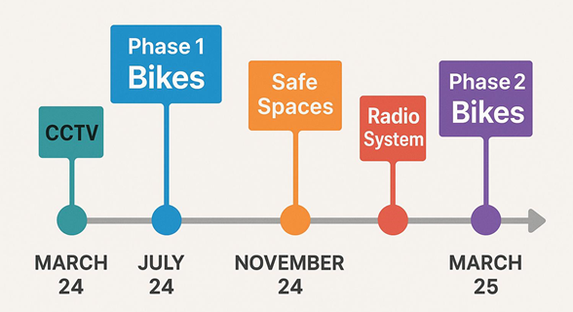

Aims and Outcomes

CCTV – Wednesbury Town Centre

Aim:
Replace outdated CCTV to improve coverage and visibility in high- footfall areas.

What We Delivered:
Installed 12 new IP, 360° pan-tilt-zoom cameras (8 replacements and 4 additional units) across the town centre.

Impact:
- Improved detection, deterrence, and real-time response to crime and ASB incidents.
- 75% increase in council-recorded ASB incidents under criminal activity categories (2024–25 vs 2023–24), attributed to improved technology and coverage enabling better CCTV operator monitoring.
- 73% of surveyed businesses rated the CCTV improvements as “very effective” in addressing safety concerns.
- Enabled evidence capture for use in enforcement action and police investigations.
- Expanded coverage eliminated key blind spots, particularly near shopfronts and transit areas.
- Contributed to increased public confidence in safety, supporting greater footfall and a more secure business environment.

CCTV – Friar Park

Aim:
Upgraded cameras covering ASB and crime hotspots.

What We Delivered:
Replaced 12 CCTV units with high-quality, internet protocol (IP) systems, improving clarity, coverage, and operational reliability.
Impact:
- Improved image quality and system reliability, enabling better evidence capture.
- Supported joint enforcement activity between the CCTV team, ASB officers, and West Midlands Police.
- Enhanced visibility at hotspot locations contributed to the prevention and disruption of ASB, particularly related to illegal off-road biking.

Deployable Cameras

Aim:
Improve ASB / Crime fly-tipping enforcement through targeted surveillance.

What We Delivered:
Purchased and deployed 8 mobile surveillance cameras, with locations identified through shared data and intelligence.

Impact:
- Enabled rapid response to emerging ASB and fly-tipping hotspots, improving operational flexibility.
- Supported identification and enforcement against offenders, including evidence gathering for fines and legal action.
- Boosted community confidence, with targeted response to identified issues.

Nuisance Bike Deterrents

Aim:
To reduce illegal off-road bike activity and related ASB.

What We Delivered:
Installed deterrent measures at 11 key greenspace locations, based on ASB data, police input, and community feedback.

Impact:
- Achieved an over 50% reduction in council-recorded nuisance bike ASB reports (from 144 in 2023–24 to 76 in 2024–25).
- Resident-led input shaped designs in key areas such as Oxford Street and Pemberton Crescent, helping to ensure local support.
- Improved safety and accessibility, especially for children, dog walkers, and older residents using key routes near schools and shops.
- Minimised damage to public green spaces and reduced the informal use of paths previously targeted by riders.
- Reinforced a visible commitment from the council to act on community concerns, building trust and local ownership.

Town Centre Radio System & Engagement Role
Aim:
To build trust, improve real-time communication, and enhance community safety coordination.

What We Delivered:
- Appointed a dedicated Community and Business Engagement Officer, funded through the Levelling Up Partnership, to lead local engagement.
- Launched a Town Centre Radio Scheme, connecting 20 businesses with council teams and West Midlands Police to improve information flow and incident response.
- Established the Wednesbury Town Centre Safety Partnership, bringing together council services, police, local businesses, transport, trading standards, and health partners for joined-up action.
- Rolled out the Safe Spaces Scheme in 10 local businesses, offering publicly accessible safe havens for anyone feeling vulnerable.

Impact:
- Significantly improved intelligence sharing between businesses and enforcement teams.
- Delivered a 75% reduction in aggressive begging and nuisance behaviour reports in the town centre (2024–25 vs 2023–24).
- 91% of surveyed residents said they felt "somewhat" or "much safer" knowing Safe Spaces were available locally.
- One participating business experienced a 300% increase in crime reporting, following sustained engagement, training, and support — improving offender identification and enforcement outcomes.
- Fostered greater confidence and collective responsibility, creating a stronger network of local businesses invested in town centre safety.
- Established the foundation for a longer-term community safety partnership model, supporting sustainability beyond the project period.

Engagement Highlights
Over a 12-month period, the Wednesbury Community Safety Project delivered extensive engagement across local communities, businesses, and strategic partners. This ensured the programme was shaped by real-world insight and remained responsive to evolving local needs.

Community Engagement:
- 1,107 residents engaged through door-to-door visits, consultations, and local events
- 53 community groups involved in shaping safety priorities and sharing local intelligence
- 49 events attended, including local safety days, youth sessions, and community outreach
- 6 partnership-led events organised, including town centre safety launches and clean-up initiatives

Business Engagement:
- 520 businesses and organisations engaged through one-to-one visits, radio scheme roll-out, and reporting training
- Participants included retailers, licensed premises, transport hubs, and service providers

Multi-Agency Coordination:
- 523 contacts with partner agencies, including police, fire, youth services, public health, and ward councillors
- Engagement included town tasking meetings, joint walkabouts, and multi-agency enforcement sessions

This high level of engagement was central to the project’s success — enabling community co-design, increasing local buy-in, and building trust between residents, businesses, and public services.

Evidence & Impact

Community Safety Infrastructure: Nuisance Bike Measures, CCTV and Deployable Cameras

Community Feedback and Co-Design
Ahead of installation, 90% of residents consulted about proposed nuisance bike deterrents either supported or were neutral about the plans. Residents provided practical, site-specific suggestions, many of which were incorporated to improve effectiveness. This approach ensured the final designs were aligned with local need and usage patterns.

Improved Perceptions of Safety
Following installation of the deterrents and the use of deployable CCTV to address hot spot issues, residents reported a notable shift in how public space was used and experienced. Community feedback consistently highlighted increased feelings of safety and ownership of local greenspace.

Examples include:
- Dog walkers noted feeling safer and more visible while using footpaths previously dominated by nuisance bike activity.
- Parents and young people described returning to parks and greenspaces they had previously avoided.
- Pathways became more accessible, especially for older residents and children travelling to school.

One resident from Oxford Crescent shared:
“My children have not been out on the greenspace in front of our property since we moved in 4 years ago. I am so pleased that the council have put this in place, I feel so much more relaxed about letting them play out, like children should.”

Environmental Impact and Disruption of ASB
Residents observed a visible reduction in drug-related activity and fly-tipping, particularly in hotspot greenspaces. In several locations, grass damage caused by bikes decreased, improving access for everyday use.

Infrastructure as a Deterrent
Deployable cameras to target hot spot locations were widely regarded as effective.
These findings complement the measured 50%+ reduction in council-reported nuisance bike ASB and the positive outcomes captured through town-wide engagement and monitoring.

Responding to Community Feedback

Engagement with residents, businesses, community groups, and partner agencies played a vital role in shaping the design and delivery of the project. Regular feedback loops ensured that the programme remained responsive and rooted in local priorities. Several key themes emerged consistently, prompting targeted interventions:

Theme | Feedback | Response
Lighting and Green Space Safety | Residents raised concerns about poor lighting in parks and alleyways, particularly during winter months, which contributed to feelings of insecurity and reduced use of public space. | The project team worked with the Parks team to install solar-powered lighting along key greenspace pathways. These were selected for their environmental sustainability and effectiveness in other local areas. Unfortunately, units at the first site were subject to theft, and the council is now reviewing more robust lighting alternatives to support ongoing safety improvements.
Youth Diversion and Positive Activity | There was a strong and repeated call for youth engagement, with residents highlighting a lack of local opportunities for young people and the link between disengagement and ASB. | The Engagement Officer worked closely with the Violence Reduction Navigator, Public Health, Neighbourhoods team, and youth services to support a local community boxing club, facilitating access to funding and resources.  In addition, the council’s youth outreach bus was deployed to hotspot areas, including Wednesbury town centre and the bus station, in direct response to business reports of youth-related ASB.
Visibility of Local Authority | Residents and businesses wanted a more visible and accessible presence from council officers and police to address day-to-day issues and increase reassurance. | Joint patrols and regular business visits were conducted by the Engagement Officer and local police. These visible interventions, alongside participation in community events, strengthened local relationships and improved confidence in local services.
Crime and ASB Reporting | Residents highlighted a lack of awareness around how to report crime and ASB, and businesses requested better guidance on where and when to escalate concerns. | The project developed a suite of practical resources, including a town centre safety map and an information pack for local businesses detailing how to report incidents effectively.

Nuisance Bike ASB: Measured Reductions

The impact of targeted deterrents and strategic CCTV deployment is evidenced by a significant year-on-year reduction in nuisance bike-related ASB reports:
- In Friar Park, council-recorded ASB reports related to nuisance bikes fell from 127 in 2023–24 to 62 in 2024–25 — a 51.2% reduction.
- Across Wednesbury as a whole, nuisance bike reports fell from 144 to 76, a 47.2% year-on-year decrease.

Residents reported a visible improvement in greenspace safety, with reduced illegal bike use and increased confidence in using local parks and paths.

Wednesbury ASB nuisance bike reports year on year-on-year comparison
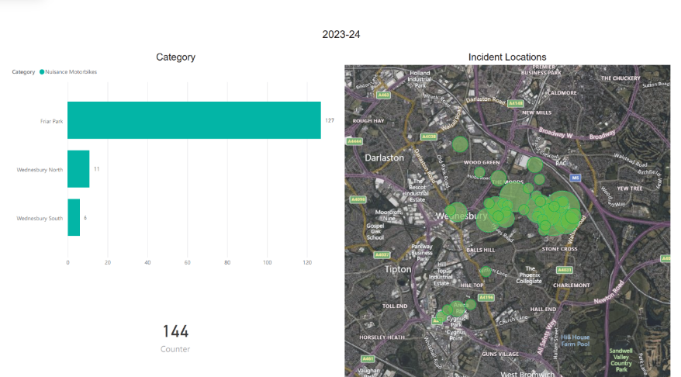
Figure 1. Nuisance Bike Council ASB reports recorded 2023-2024 - 144
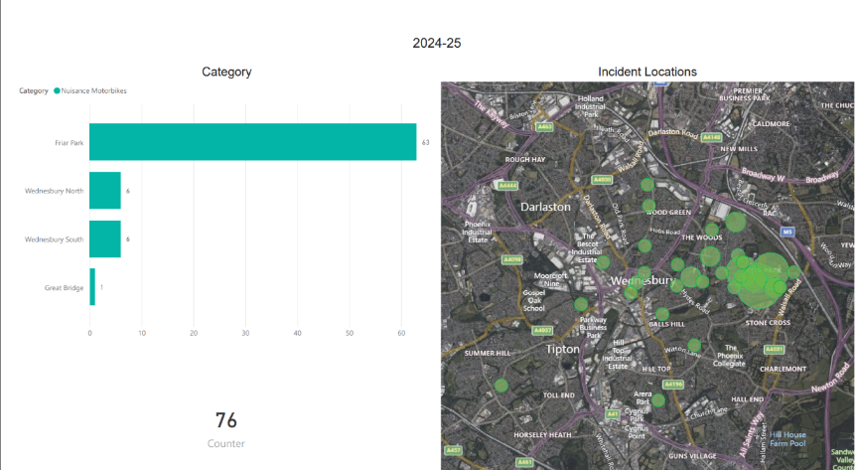
Figure 2. Nuisance Bike Council ASB reports recorded 2024-2025 - 76
CCTV & Radio System

To support sustained reductions in crime and ASB, the project implemented a comprehensive town centre safety infrastructure, including upgraded CCTV coverage, a new business radio network, and designated Safe Spaces across Wednesbury.

As part of this, a Town Centre Safety Map was developed to raise awareness of safety resources. The map, which highlighted CCTV locations, radio-linked businesses, and Safe Spaces, was distributed to all participants in the scheme.

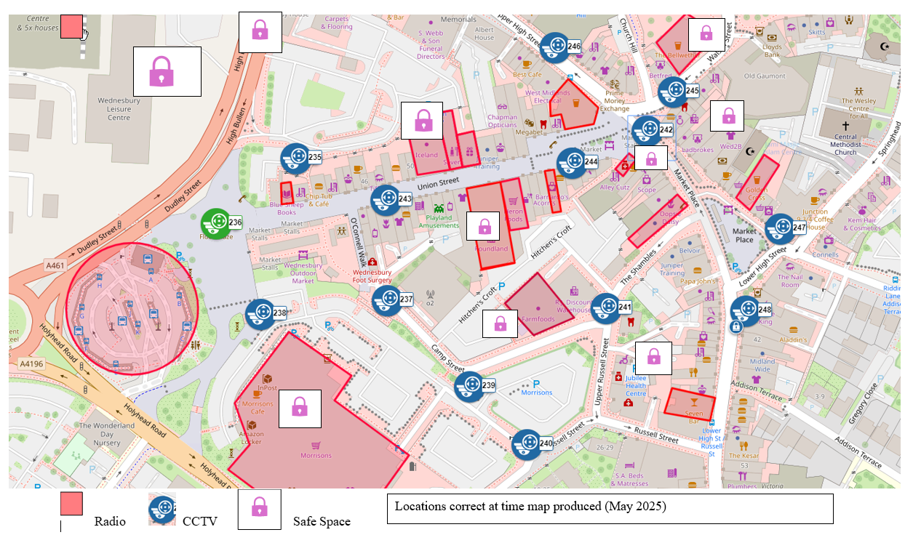
Figure 3. Map of Wednesbury town centre radio, CCTV and safe space locations provided to town centre businesses.

In response to the March 2024 town centre safety survey, in which businesses called for better coordination with enforcement partners, a formal Town Centre Safety Partnership was established.

This multi-agency group includes:
- Local businesses and retailers
- Council services (ASB, CCTV, Licensing, Neighbourhoods, Environmental Protection)
- West Midlands Police and local transport providers (bus station, Metro)
- Public Health, Fire Service, Regeneration, Leisure, Education, and voluntary sector partners

This partnership has enabled:
- Faster intelligence sharing and a joint response to persistent offenders
- Coordinated safety events and local enforcement activity
- A sustainable platform for ongoing dialogue, problem-solving, and joint planning

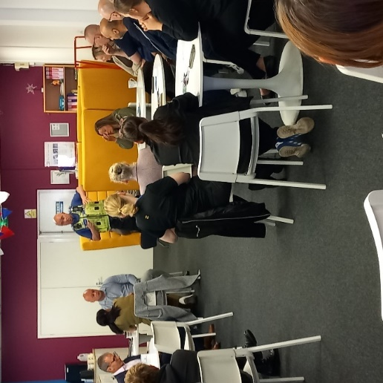
Figure 4. Police presenting at partnership safety meeting

The group also supported the identification of 20 businesses to take part in the new radio system rollout, prioritised based on levels of reported crime, location, and commitment to joint working.

Ongoing partnership activities include:
- Quarterly safety partnership meetings
- Regular safety bulletins and awareness sessions
- Shared guidance, training, and radio system maintenance
- Collaborative safety campaigns and events

Addressing Underreporting

A recurring issue identified during the project was underreporting of crime and ASB by local businesses. Barriers included limited time, lack of clarity on reporting processes, and a perception that action would not follow.

In response, the council’s Community Safety, CCTV, and ASB teams provided:
- One-to-one engagement and support
- Practical training on how and when to report
- Assurance that all reports would be monitored and responded to

This direct support resulted in a significant increase in crime reporting by several businesses, improving intelligence for enforcement teams and helping to break the cycle of repeated, unchecked offending.

  - Business 1 Case Study:

Turning underreporting into partnership-driven prevention

In early 2024, a retailer in Wednesbury Town Centre—referred to here as Business 1—was experiencing frequent shoplifting, abuse towards staff, and repeat anti-social behaviour. Despite this, most incidents were going unreported due to lack of time, low confidence in follow-up, and a belief that low-value thefts wouldn’t be acted upon.

Through the Levelling Up Partnership, the business received dedicated support as part of the town centre safety initiative. This included:

- Weekly engagement drop-ins
- Liaison with their head office security team
- Guidance on how and when to report crime and ASB
- Coordination with ASB officers, CCTV operators, and West Midlands Police

As a result, reported crime rose by over 300% between February 2024 and February 2025.
This increase reflected better reporting, not more incidents—and allowed agencies to respond decisively.

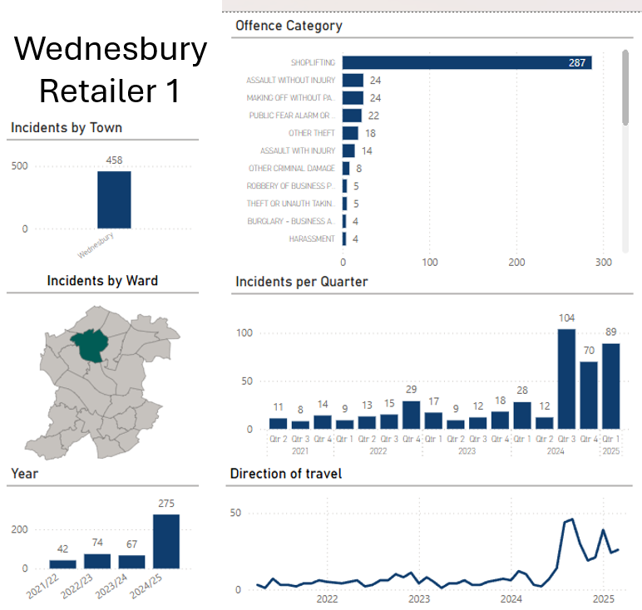
Figure 5. Screenshot of crime report data for “Business 1” in the town centre

The improved reporting led to:
- Identification and intervention for repeat offenders
- Use of CCTV to support police investigations
- Targeted patrols and joint enforcement visits

In turn, the business made visible changes, including:
- A new store layout to improve visibility
- Lockable doors for high-risk product areas
- Hosting the launch of the Safe Spaces Scheme
- Joining the Town Centre Radio Network and Safety Partnership
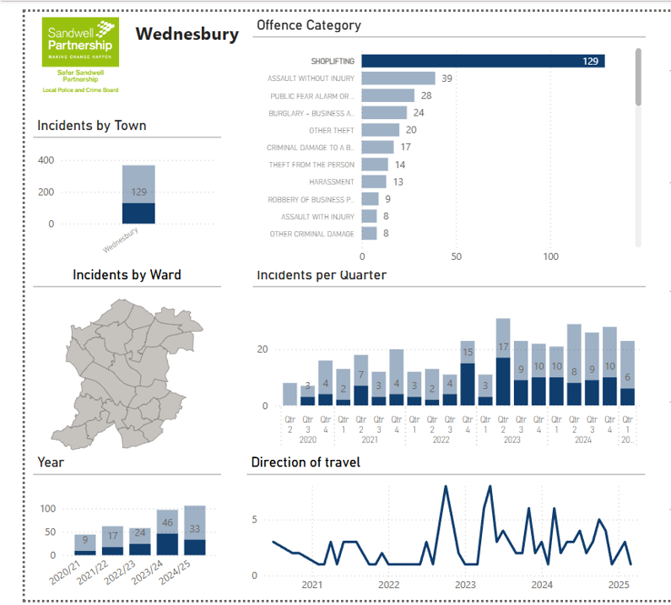
Figure 6. Police Crime Data for Union Street, Market Place, Upper High Street and Lower High Street – Location of town centre CCTV and Radios.

This case demonstrates the power of trusted partnerships and ongoing support. What began as a disconnected business now stands as an active contributor to town centre safety, setting an example for others.

Impact at a Glance
- 300% increase in crime reporting (Feb 2024–Feb 2025)
- Enforcement action against repeat offenders
- Store safety improvements implemented
- Active partner in Safe Spaces and Radio Scheme

Tackling Misinformation & Strengthening Retail Resilience

A widespread misconception among retailers and the public was that shoplifting under £200 would not be pursued. This belief contributed to chronic underreporting and emboldened repeat offenders.

To address this, the partnership:
- Shared updated legal guidance, including the new Crime and Policing Bill (2025), which enables up to 7 years’ imprisonment for repeat shop theft, regardless of value.
- Used business networks and safety meetings to raise awareness and correct misinformation.
- Encouraged retail staff to report every offence, reinforcing that every report matters.

Retailers responded proactively:
- Installing barriers at key access points
- Hosting fire service-led sessions on evacuation and safety plans
- Redesigning stores to improve surveillance and staff safety

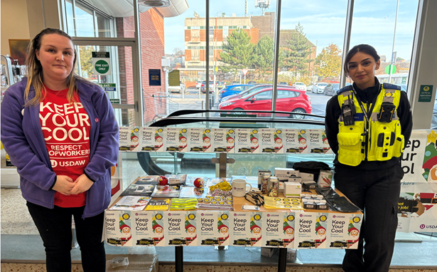
Figure 6. “Freedom from Fear” Wednesbury Event

Localised Impact vs. Borough-Wide Trends

According to the latest West Midlands Police (WMP) data, total recorded crime in Wednesbury rose from 4,712 to 4,867 offences, a 3.29% year-on-year increase.
While this headline figure indicates a Wednesbury rise, a closer look at the data reveals a more encouraging picture in specific locations targeted by the project.

In streets where CCTV, the radio scheme, and joint enforcement activity were concentrated, recorded crime actually decreased – demonstrating that the targeted interventions are having a positive early impact.

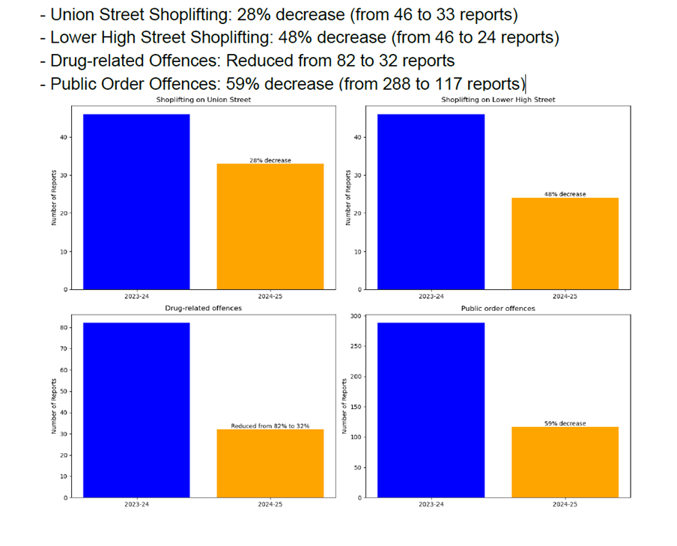
Figure 7. Police crime reports from 4 streets in Wednesbury Town Centre 2023-24 to 2024-25 year-on-year comparison.

ASB Trends and the Role of Improved Reporting

While council-recorded ASB incidents in Wednesbury town centre have increased, this trend is primarily attributed to:

- Proactive encouragement for businesses and residents to report ASB
- Upgraded CCTV systems with greater coverage and clarity
- Vigilant council operators who monitor footage in real time with improved CCTV technology

These factors have led to more accurate, transparent reporting—not necessarily more ASB.

It is therefore reasonable to conclude that without these proactive measures, both crime and ASB levels would likely have been significantly higher.
Although the full impact may not yet be reflected in broader statistics, early indicators are encouraging, particularly in areas where interventions have been concentrated.

Wednesbury stands out as one of the few localities where targeted safety concerns have already seen a measurable reduction—a direct result of coordinated, collective efforts from partners, businesses, and the local authority.

  - Safe Spaces Scheme
  - As part of the project, 10 Wednesbury town centre businesses joined the Sandwell Safe Space Scheme, offering their premises as refuges for members of the public who feel unsafe or need support.
  - Staff at each participating business received training to respond compassionately and effectively, helping to create an accessible network of support throughout the town.
  - At the scheme’s launch event, 91 members of the public completed a Safe Space Questionnaire. The feedback demonstrated strong community confidence in the initiative:
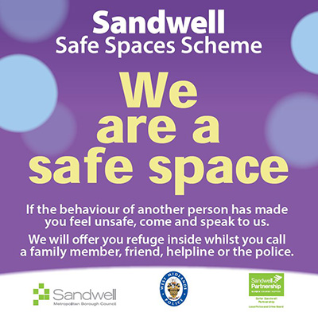
- 91% of respondents said they feel somewhat or much safer knowing that designated Safe Spaces are available in the town centre.

- 92% indicated they would use a Safe Space if needed or have already done so.

- An overwhelming 97% said they would recommend the Safe Spaces Scheme to others.

These results highlight the scheme’s positive impact on public confidence and its potential to foster a safer, more supportive environment for all residents

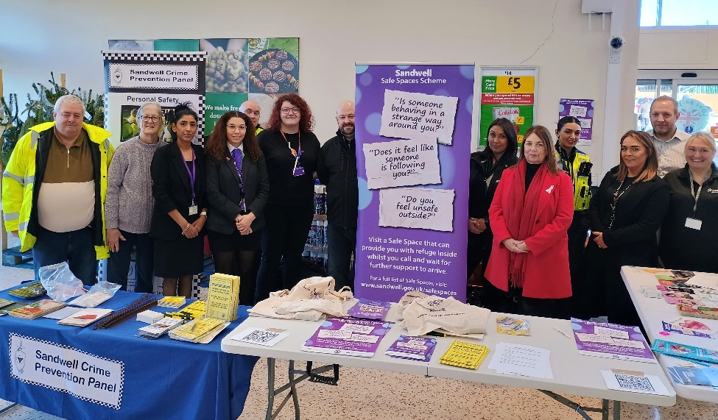
Figure 8. Wednesbury Safe Spaces launch event with partners and leader of the council.
Outcome Metrics
Outcome Measure | 2022-23 Figures | 2024-25 Figures
1. Recorded crime and ASB in Wednesbury
Total recorded crime (WMP Crime Data) https://www.westmidlands.police.uk/area/your-area/ | 4712 offences | 4867 offences | An overall increase of 3.29% in recorded crime.  However, more detailed analysis indicates reductions in crime at project intervention sites, reflecting early positive local impact despite the broader Wednesbury wide trend.
Sandwell Council recorded all Wednesbury ASB (Insights & Quality Officer – Sandwell Council ) | 525 new incidents / 70 new cases | 653 new incidents / 80 new cases | The rise in reporting reflects enhanced visibility, upgraded CCTV, and targeted engagement—not necessarily an increase in ASB, but better detection and recording.
2. Number of council ASB nuisance bike reports where bike measures have been installed. Sandwell Council recorded all Wednesbury ASB (Insights & Quality Officer- Sandwell Council ) | 127 | 63 | A 50.4% reduction in nuisance bike reports following environmental design measures, demonstrating clear success in deterring illegal bike use in priority locations.

Social Value and Community Benefits

The project delivered strong social value across several key pillars, embedding community benefit and sustainability into every stage of planning and delivery.

Pillar - Local Spend – “Buying Locally”
 | - The procurement process included a 10% social value weighting for suppliers located within a 20-mile radius of Sandwell.  - A local radio supplier, based just 0.1 miles from the CCTV control room, was successfully appointed.  - This approach supported the local economy and encouraged ongoing supplier-community relationships.
Pillar - Employment and Skills

 | - One local young person was offered a week-long work experience placement through the main project contractor.  - 10 local businesses and organisations received Domestic Abuse awareness training as part of their onboarding into the Safe Space Scheme.  - One employment support session was delivered by ex-offenders completing community payback.  (See Appendix C: Clean-Up Project)
Pillar – Community Benefits

 | - Early signs of crime and ASB reduction have been observed in project-targeted locations.  - Businesses, residents, and community organisations were better connected to local services, enhancing safety, wellbeing, and trust.
Pillar – Environment

 | - A Green Space Clean-Up was delivered through a collaboration between the community payback team and a local boxing club.  This led to:  - Reduced fly-tipping  - Improved cleanliness  - Stronger civic pride  (See Appendix C: Clean-Up Project)

Community consultation shaped how contractors could deliver meaningful, locally rooted benefits.
One example:
- The contractor responsible for installing bike measures also repaired damaged fencing at a local boxing club recently affected by a break-in.
- In return, the boxing club opened its premises for contractor use during works.

This mutual support model saved costs, avoided disruption, and strengthened local partnerships.

Outcomes & Learning

This project delivered a number of valuable outcomes that now inform good practice across the borough. The learning gathered has been drawn from data, evaluation, lived experience, and real-time feedback from residents, businesses, and partners.

1. Infrastructure Enhancements Drive Visibility and Confidence
- CCTV schemes (town centre and Friar Park) have proved vital not only in deterring crime and ASB but also in enabling effective case resolution. The presence of high-quality footage supported enforcement and built public trust.
- The radio network encouraged better collaboration and rapid response among businesses, council services, and police. It provided reassurance and helped establish a sense of shared responsibility for town centre safety.
- Safe Spaces added a critical wellbeing dimension, creating visible signs of community care, particularly valued by vulnerable or isolated individuals.

2. Underreporting Can Mask the True Scale of Issues
- One of the most significant challenges identified was chronic underreporting by both businesses and residents.
- Many businesses assumed that shop theft under £200 would not be acted upon, leading to a culture of disengagement. Clarifying this misconception and linking reporting to visible enforcement proved transformative.
- Once supported and equipped to report, partners such as “Business 1” saw over 300% increases in reporting, exposing repeat offenders and enabling coordinated responses.

3. Partnerships Are Essential to Sustainable Safety
- The creation of a Town Centre Safety Partnership demonstrated the power of multi-agency working. Joint intelligence sharing, joint patrols, and aligned interventions increased efficiency and trust.
- Cross-sector working (e.g. licensing, environmental health, public health, and youth services) ensured that safety was not treated in isolation but addressed as part of a wider public health and place-based strategy.

4. Community Engagement Builds Lasting Buy-In
- Early and continuous engagement with residents, retailers, youth, and community groups meant that interventions were relevant and locally owned.
- Residents and businesses directly influenced solutions—such as the choice of lighting in parks, or the layout changes in shops—which made those changes more likely to succeed and endure.
- The use of feedback loops (e.g. safety surveys, listening sessions, drop-ins) ensured community voices remained central throughout.

5. Visible Action Restores Confidence
- Visible results—such as reductions in nuisance bike reports and joint patrols—reassured the public and showed that reporting leads to action.
- This visibility also enabled broader communication campaigns, including Freedom from Fear and CCTV & radio map distribution, helping more people engage with the work.

6. Social Value Adds Community Impact
- Local procurement, youth work experience, ex-offender support, and domestic abuse training for businesses added value far beyond the original safety brief.
- Collaboration with local organisations (e.g. boxing club) to co-deliver improvements reinforced the principle that safety is a shared community outcome, not a top-down directive.

7. Data Must Be Interpreted with Context
- Increases in ASB figures were largely a positive indicator of improved reporting, not a failure of intervention.
- Where project work was most concentrated, crime and ASB actually decreased, despite borough-wide rises.
- These early wins provide a foundation for wider rollout, with data now being used more confidently to target and justify further intervention.

Summary

This project has demonstrated that safety is both visible and relational. It is built not just through enforcement and equipment, but through trust, communication, and shared ownership. The challenge now is to embed the infrastructure, relationships, and learning into long-term systems that continue to grow safer, stronger communities.

Appendices
- Appendix A: Nuisance Bikes
- Appendix B: Engagement
- Appendix C: Clean Up Project

